**Inventory System Documentation**

**Introduction**

An inventory/stock system is an easy way to keep track of what is in or out of your inventory and how it was stored or retrieved. In addition to that the system will be able to connect two types of users. One who will be requesting and another to approve or deny the request.

**Overview**

The system will workflow will be as follows, first the admin will sign-up for security measures the he/she will proceed to create a category then assign an item to that category. Secondly admin will view all list of employees to identify who made a request, after that the admin will be able to view requests as a different section showing the employee name, item requested, amount needed, two buttons one for accepting and the other for denying.

The system will include another type of user who is an employee, this one will first sign-up for security then proceed to the item requisition form, after completing the form his/her system will send a notification to the admin’s system, when the admin answers the employee will also get a notification in the “Notifications” tab. Lastly the employee will view terms and conditions complying to the Item Requisition Form, and old exceptions about an item.

Every aspect of the system will be recorded to simplify the transaction table keep track of what took place in the system.

**Keystones**

* **Category**
* **Admin**
* **Notification/Request**
* **Items**
* **Employees**
* **Suppliers**

**Functionality**

**Admin:** Admin will be the system master and, in the database, his/her column will be

consisted of: ID, username, password, address, phone and email.

**Role:** Signing Up

Creating categories

Adding item into the category

Viewing Orders

Receiving Notifications

Viewing Employee’s info

Approving Orders or Denying

**Category:** A category will be the keeper similar items for easy stocking techniques,

In the database its columns will be: ID, Category name, Description.

**Role**: Assigning new and updating items.

Validate and functionalized to safely keeping meta-data about an item.

**Request:** A request will be a set of data an employee will send to the admin, and in the

Database its column will consist of: ID, amount, date, item ID.

**Role:** Real-time notifications to administrators for order review.

Tracking all orders made in the past.

Denial or approval from the system admin.

Ensuring the request was successfully made by the employees.

**Employees:** These are the people who make requests and notify the admin what’s

Needed by them. In the database their columns will be: ID, Username,

Password, profile picture, position, department, immediate supervisor.

**Role:** Giving & updating personal information.

Requesting items.

Retrieving item.

**Suppliers:** These are people who the items came from, and their information is needed

For future purposes. In the database this how their column would look: ID,

Full name, address, phone, email and description.

**Role:** Keeping a supplier’s info

**Item**: This table will store data from these columns: ID, name, amount, state of item,

Depreciation rate, serial number, supplier ID, category ID.

**Role:** Creating, Updating, Deleting an item.

Viewing all or specific item.

**Request & Item:** This table will store data from these columns: ID, date of order,

Order ID, employee ID.

**Role:** Keeping related foreign keys.

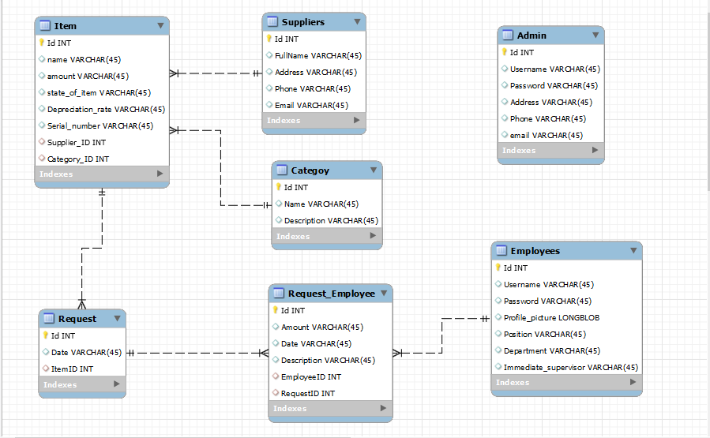

**Above is the inventory system ERD**

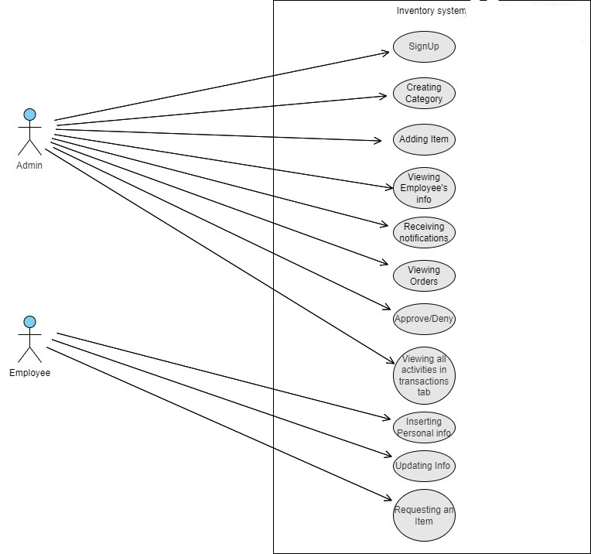

**Inventory system Use-case diagram**